Research Software Engineer Challenge

* Walk-Through ([GitHub](https://github.com/N-HAFSA/Senior-SER.git))

The application is a check-in system to register the traffic in a company.

For that we have 3 main entities:

* The company
* The Employee
* The check-in (Mark)

The check-in entity is the relationship between the employer, the employee and date of marking the check-in.

Well for that we made the following functions:

*Create an Employer:*

* <http://127.0.0.1:5000/signup>

In this section, we will allow an employer to register for the senior API by providing a username and a unique password in a JSON format using the POST method.

{"name":"senior","password":"senior"}

*Sign in the Employer:*

* <http://127.0.0.1:5000/signin>

Now we have successfully registered an employer. Let’s go-ahead to allow the employer who just registered to login in order to generate a temporary random token to access the Points/check-in table.

We do the same for the employee except that we add an input as a reference to the employer as follow:

{"name":"senior","password":"senior","employerId":2}

*Register an Employee:*

* <http://127.0.0.1:5000/register>

*Login an Employee:*

* <http://127.0.0.1:5000/login>

*List all employees:*

* <http://127.0.0.1:5000/employees>

There is a function that generate tokens in order to allow only registered users to access and perform a set of API operations against the Points/check-in table.

We receive the value of the token, that expires in 30 min, after the login that we need to include in our request in order to add a new check-in or list the history of all the previous check-ins:

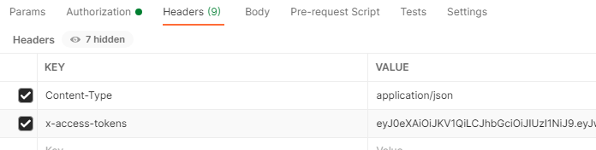

*Create a Mark/Check-in:*

* <http://127.0.0.1:5000/mark>

*List all check-ins for the logged user:*

* <http://127.0.0.1:5000/marks>
* Further information

*Technologies:*

* Python (Flask)
* SQLite

*Response Time:* about 48ms

*Insights:*

* In terms of making the service lighter and responsive we might use google cloud API service named Apigee more specifically using the proxy which allow you to optimise the use of your API by calling multiple back-end services at the same time which give you control of the flow.
* We might use the geolocation / IP address of the Company to double check the attempts to access the service if they are from the company, it self or some try to hack into the system,

By: Hafsa NOUIRI

14-04-2021